We have gathered here for one of the most important topic and one of the most critical issue which should be under consideration. Gurudev annu mein bhibhu concept. Har kan mein har rang mein bus wohi hai samaya.

Activity one.
Share some of your happy moment of your life from your childhood.
Most off them will be nature and members of family.
Playing outdoors, gardening, family picnics and going to market etc.


Emotional Perspective:
Imagine a world where our children can no longer experience the beauty of a clear blue sky, the serenity of a lush green forest, or the tranquility of a pristine beach.


The thought of losing these natural wonders is heartbreaking. Every action we take today impacts the world we leave for future generations. By making small changes in our daily lives, we can preserve the beauty and health of our planet for those who come after us.
Scientific Perspective:
From a scientific standpoint, the evidence is clear: human activities are significantly impacting the environment. Here are a few key points:
- Climate Change: The burning of fossil fuels releases greenhouse gases like carbon dioxide (CO₂) into the atmosphere, leading to global warming. This results in more extreme weather events, rising sea levels, and disrupted ecosystems.
- 

- Deforestation: Cutting down forests for agriculture and urban development reduces biodiversity and increases CO₂ levels, as trees play a crucial role in absorbing carbon dioxide.
 
- Pollution: Plastic waste, chemical runoff, and air pollution are contaminating our oceans, rivers, and air, harming wildlife and human health.
 
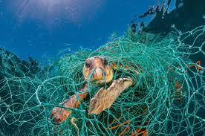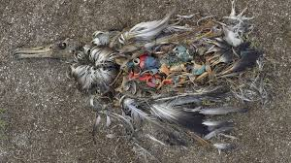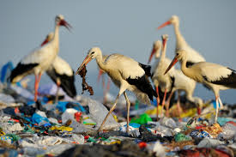


Call to Action:
We have the power to make a difference. Here are some steps we can take:
- Consipiracy against us: Buy Now: Show some parts of movie and ask people to reuse, do not buy more. Less material consumption itself is a big help.
- Reduce, Reuse, Recycle: Minimize waste by recycling and reusing items. Avoid single-use plastics whenever possible.
- Conserve Energy: Use energy-efficient appliances, switch to renewable energy sources, and reduce energy consumption by turning off lights and unplugging devices when not in use.
- Support Sustainable Practices: Choose products and companies that prioritize sustainability. Support policies and initiatives that protect the environment.
By combining our emotional connection to the natural world with scientific understanding, we can inspire meaningful action to protect our planet. 🌱💚

